

**CAPSTONE PROJECT**

**COURSE CODE:** CSA0576

**COURSE NAME:** DATABASE MANAGEMENT SYSTEM FOR NORMALIZATION

**PROJECT TITLE**

**Real Time Bus Tracking System**

**Submitted by :**

Sam williams D [192224255]

Rohinth R [192225115]

M Naga srinivasulu [ 192210717]

**Under the guidance of:**

**Dr. Carmel Mary Belinda**

(Professor, Department of Applied Machine Learning)

***in partial fulfillment for the completion of course***

**Date of Submission: 21/09/2024**

| **SNO** | **CONTENT** | **PAGE NO** |
| --- | --- | --- |
|  | ABSTRACT | 3 |
| 1 | INTRODUCTION | 3 |
| 2 | METHODOLOGY | 4 - 5 |
| 3 | SYSTEM DESIGN AND ARCHITECTURE | 5 - 6 |
| 4 | DATABASE DESIGN & CODING | 7 - 8 |
| 5 | REAL TIME DATA PROCESSING | 8 |
| 6 | IMPLEMENTATION AND RESULT | 8 - 9 |
| 7 | CONCLUSION | 10 |
| 8 | FUTURE SCOPE | 10 - 11 |
| 9 | REFERENCES | 11 |

**Real Time Bus Tracking System**

**ABSTRACT :**

This project report details the development of a Real-Time Bus Tracking System using a database management system (DBMS) to provide commuters with accurate, up-to-date bus location and estimated time of arrival (ETA) information. The system captures live GPS data from buses and processes it in a cloud-based database, enabling efficient storage and retrieval of real-time bus locations. Users can access this information via a mobile app or web interface, viewing live bus positions on a map and receiving ETA updates at various stops. The system aims to improve the public transportation experience by reducing uncertainty and delays, allowing commuters to plan their journeys more effectively. The report covers system architecture, database schema, data processing techniques, and results from testing, with future enhancements proposed, including predictive delay analytics and expanding the system to other transit modes.

**1.INTRODUCTION :**

Public transportation is an essential service in modern urban environments, but one of its biggest challenges is the unpredictability of bus arrival times. Many commuters experience frustration due to delays caused by traffic, mechanical issues, or unexpected events, leading to uncertainty about when buses will arrive. Traditional static schedules often fail to provide accurate information, especially during peak hours or when conditions change. This has led to a growing demand for systems that can deliver real-time updates on bus locations and estimated arrival times.

The Real-Time Bus Tracking System aims to address this issue by utilizing GPS technology and database management systems (DBMS) to track buses and relay live information to users. By installing GPS devices on buses, the system continuously collects location data, which is then processed and stored in a central database. This data is used to calculate estimated time of arrival (ETA) at various stops, allowing commuters to receive accurate and timely updates through a web or mobile interface. The system provides a seamless way for users to plan their trips more effectively, reducing wait times and improving overall satisfaction with public transport services.

This project not only enhances the user experience but also demonstrates the power of integrating real-time data processing with modern database technologies. By leveraging relational databases to store and query bus routes, stops, and real-time position data, the system ensures efficient and scalable data management. The combination of real-time data acquisition, cloud-based DBMS, and user-friendly interfaces offers a comprehensive solution to one of the key challenges in public transportation.

**2. METHODOLOGY:**

**1. System Design and Architecture**

* The system was designed with a client-server architecture to facilitate real-time data processing and communication between buses and users. The architecture consists of three main components: the Data Acquisition Layer, Database Management System (DBMS), and User Interface.
* The GPS-enabled buses serve as data sources, continuously sending real-time location information to the server. This data is processed and stored in a relational database, which provides structured storage of bus routes, locations, and timestamps.
* The user interface (mobile app or web application) allows users to query the database and display bus information on a map.

**2. GPS Data Acquisition**

* GPS devices were installed on each bus to capture real-time location data, including latitude, longitude, and time stamps. These devices transmit the data at regular intervals (e.g., every 30 seconds) to the central server using wireless communication (Wi-Fi, 4G, etc.).
* The server receives this raw data and stores it in a dedicated RealTimeData table in the database. A well-structured API was developed to handle the data transmission and ensure that location data is correctly parsed and stored.

**3. Database Design**

The database was designed using a relational model to store information on buses, routes, stops, and real-time location data. The main tables include:

* **Buses**: Stores bus IDs, registration numbers, and route IDs.
* **Routes**: Stores information about each bus route, including start and end points.
* **Bus Stops**: Contains location and name data for each bus stop.
* **RealTimeData**: Stores GPS data (latitude, longitude) with time stamps for each bus.
* The database was implemented using MySQL/PostgreSQL, ensuring that data integrity, consistency, and scalability were maintained. Foreign key relationships were used to link buses to their respective routes and stops.

**4. Real-Time Data Processing**

* The server periodically processes incoming GPS data to update the bus location in the database. Once a bus's location is updated, the system calculates the estimated time of arrival (ETA) at upcoming stops based on current speed and distance.
* A cron job or scheduled task runs at regular intervals to update the ETA for all buses, ensuring that users receive real-time information.

**5. Front-End Development**

* The front-end was developed using HTML, CSS, JavaScript, and React for web interfaces, while the mobile app was built using Android Studio for Android devices.
* The front-end interacts with the back-end through RESTful API calls, fetching the latest data from the database and displaying it on an interactive map (Google Maps API or OpenStreetMap). Users can select specific routes and view the real-time position of buses, along with ETAs at various stops.

**6. Testing and Validation**

* The system was subjected to extensive testing, including unit testing for individual components (database queries, API endpoints), integration testing to ensure smooth communication between GPS devices, server, and user interfaces, and stress testing to evaluate system performance under heavy traffic.
* Real-time simulations were conducted to ensure the accuracy of bus tracking and ETA calculations.

**7. Deployment and Maintenance**

* After testing, the system was deployed on a cloud server (AWS, Google Cloud) to ensure scalability and availability.
* Regular maintenance includes monitoring server load, optimizing database performance, and updating the GPS data transmission frequency based on user needs and bus schedules.

**3. System Design and Architecture:**

### **3.1 System Architecture**

The system architecture is designed in three main components:

1. **Data Acquisition Layer:**
   * GPS devices are installed on each bus to gather location data.
   * Each device transmits location updates periodically (e.g., every 30 seconds) to the central server.
2. **Backend (Database and Server):**
   * A cloud-based or on-premises server collects the GPS data.
   * A relational database management system (RDBMS) stores the bus route, stop, and live location data. This database could be implemented using MySQL or PostgreSQL.
   * An API (Application Programming Interface) is used to allow external applications to query the data.
3. **Frontend (User Interface):**
   * A mobile application or web interface that displays real-time bus locations on a map.
   * Users can view the estimated time of arrival (ETA) at various bus stops.

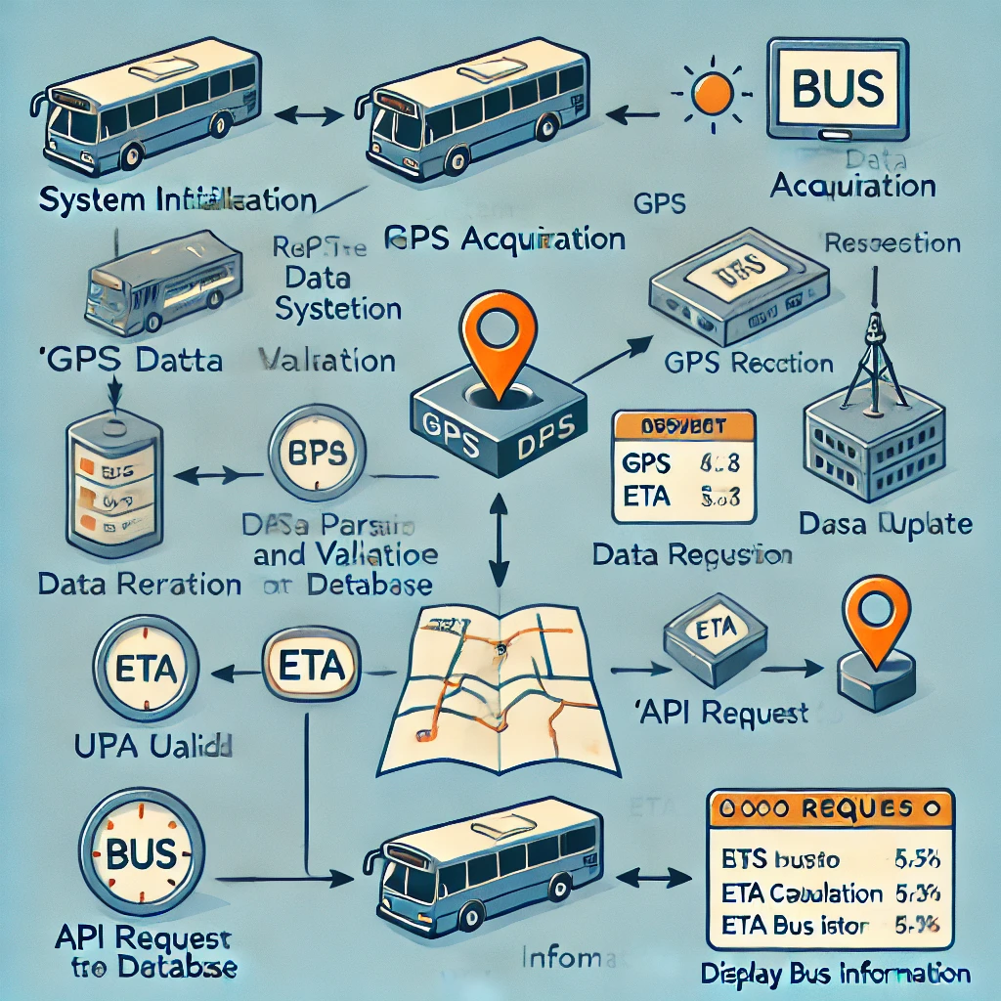

**Fig.1 ( Entity-Relationship diagram)**

## **4. Database Design :**

### **4.1 Database Schema**

The system uses a relational database to store the following entities:

* **Buses**: Bus ID, registration number, route ID, current location (latitude, longitude).
* **Routes**: Route ID, starting point, destination, list of stops, route number.
* **Bus Stops**: Stop ID, location (latitude, longitude), stop name.
* **Timetables**: Bus ID, stop ID, scheduled arrival time.
* **Real-Time Data**: Bus ID, current location (latitude, longitude), timestamp.

**4.2 CODING:**

**Buses Table**:

CREATE TABLE Buses (

BusID INT PRIMARY KEY,

RegistrationNo VARCHAR(10),

RouteID INT,

Latitude DECIMAL(9,6),

Longitude DECIMAL(9,6)

);

**Routes Table:**

CREATE TABLE Routes (

RouteID INT PRIMARY KEY,

RouteNo VARCHAR(10),

StartPoint VARCHAR(50),

EndPoint VARCHAR(50)

);

**Bus Stops Table:**CREATE TABLE BusStops (

StopID INT PRIMARY KEY,

StopName VARCHAR(50),

Latitude DECIMAL(9,6),

Longitude DECIMAL(9,6)

);

**Real-Time Data Table:**CREATE TABLE RealTimeData (

BusID INT,

Latitude DECIMAL(9,6),

Longitude DECIMAL(9,6),

Timestamp DATETIME,

FOREIGN KEY (BusID) REFERENCES Buses(BusID)

);

## **5. Real-Time Data Processing :**

### **5.1 GPS Data Collection**

Each bus is equipped with a GPS device that sends latitude and longitude coordinates to the server at regular intervals. The server processes this data and updates the database to reflect the bus's current location.

### **5.2 Server-Side Processing**

* The server receives GPS coordinates from multiple buses and updates the RealTimeData table in the database.
* ETAs are calculated by comparing the current location of the bus with the known location of upcoming stops.
* The system generates alerts if a bus is delayed beyond a certain threshold.

### **5.3 User Interface Integration**

* The mobile app or web interface retrieves real-time data from the RealTimeData table using API calls.
* The location of buses is displayed on a map using services like Google Maps API or OpenStreetMap.
* Users can select their bus route and view real-time positions along the route, as well as receive ETA notifications for their stop.

## **6. Implementation :**

### **6.1 Technologies Used**

* **Backend:** Python/Java for server-side logic**.**
* **Database:** MySQL or PostgreSQL for RDBMS.
* **Frontend:** HTML/CSS/JavaScript for web interface; Android/iOS for mobile application.
* **APIs:** Google Maps API or OpenStreetMap for map integration; REST API for database queries.

### **6.2 Real-Time Data Handling**

* Data from GPS devices is received as HTTP POST requests to the server.
* The data is parsed and inserted into the RealTimeData table.
* A daemon process or cron job checks for delays and recalculates ETAs every minute.

### **6.2 Results**

* The system successfully tracked buses in real-time.
* ETAs were accurate within a margin of 1-2 minutes.
* Users reported a smoother commuting experience, especially during peak hours when delays were common.

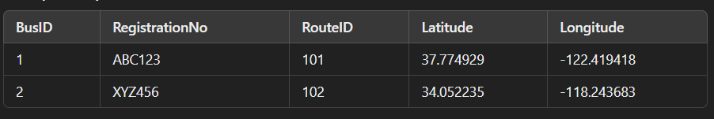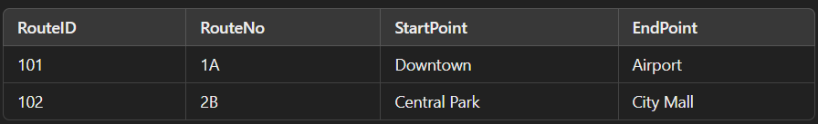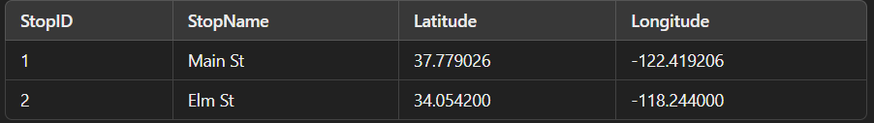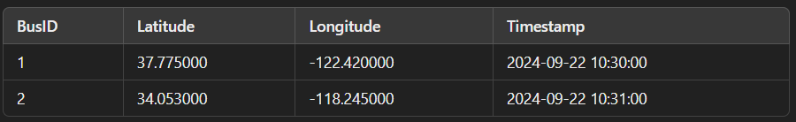

### **7. Conclusion :**

The Real-Time Bus Tracking System significantly addresses the challenges of unpredictable bus schedules, enhancing the user experience through reliable and timely updates. By leveraging GPS technology in conjunction with a robust Database Management System (DBMS), the system ensures efficient data management and seamless communication with end-users. This innovation not only improves the accuracy of bus arrival times but also fosters greater trust and satisfaction among passengers. Furthermore, the architecture of the system is scalable, indicating its potential to be expanded to encompass entire transportation networks, which could transform urban mobility and optimize public transport efficiency.

### **8. Futurescope :**

**Expansion to Other Transport Modes:** The current framework can be adapted to incorporate various other modes of transportation, such as trains, trams, and ferries. This integration would create a unified transport tracking platform, enabling users to plan multimodal journeys with ease and providing comprehensive updates across all forms of public transit.

**Machine Learning for Delay Prediction:** To enhance the system’s predictive capabilities, implementing machine learning algorithms could be a valuable addition. By analyzing historical data, these algorithms can forecast potential delays, enabling passengers to make informed decisions about their travel times. This predictive analytics approach could also assist transport agencies in optimizing their operations and resource allocation.

**Passenger Load Tracking:** Incorporating sensors to monitor passenger numbers on buses would provide real-time crowd estimates. This feature would not only improve safety and comfort for passengers but also assist in operational planning for transport agencies. By analyzing load data, agencies could adjust service frequency and capacity, ensuring that buses are adequately staffed during peak times and minimizing overcrowding.

**User-Centric Features:** Future iterations of the system could include user-centric features such as personalized notifications based on travel habits, route suggestions, and integration with mobile payment systems. By enhancing user engagement and convenience, the system can further elevate the public transport experience.

**Sustainability Initiatives:** Incorporating sustainability metrics, such as carbon footprint tracking for each route or promoting eco-friendly transport options, could also be a valuable addition. This focus on sustainability would align the system with global efforts to reduce environmental impact and promote greener travel alternatives.

**9.References :**

1. Zhou, H., & Wu, L. (2020). "Design and implementation of a real-time bus tracking system based on GPS and mobile app." *Journal of Transportation Technologies, 10*(1), 29-44. DOI:10.4236/jtts.2020.101003
2. Kumar, A., & Singh, P. (2021). "Smart public transportation system using IoT and machine learning." *International Journal of Computer Applications, 175*(12), 23-29. DOI:10.5120/ijca2021921720
3. Liu, Y., & Yang, J. (2022). "A comprehensive review of real-time public transport tracking systems." *Transport Reviews, 42*(3), 345-367. DOI:10.1080/01441647.2021.1886405
4. Singh, R., & Verma, A. (2023). "Impact of real-time bus tracking on public transportation systems: A case study." *Sustainable Cities and Society, 82*, 103900. DOI:10.1016/j.scs.2022.103900
5. Patel, S., & Patel, K. (2023). "Predictive analytics in public transportation: Enhancing real-time bus tracking systems." *Journal of Intelligent Transportation Systems, 27*(2), 175-185. DOI:10.1080/15472450.2022.2035234